EMPLOYEE ANALYSIS – PROJECT REPORT

1. Introduction
Employee Analysis is an important application of data analysis and Business Intelligence that helps organisations understand their workforce and make better human-resource decisions. The Employee Analytics Dashboard provides a visual analysis of employee information across several dimensions, including:
Dataset Information
Source: Kaggle / **https://www.kaggle.com/datasets/desolution01/messy-employee-dataset
Domain: Human Resources
* Department
* Region
* Employee status
* Performance score
* Joining year
* Age
* Salary
* Remote work
* Department and regional salary distribution
* Performance by year
* Employee-level details
The dashboard converts employee data into interactive visualizations and Key Performance Indicators (KPIs), allowing management to quickly identify workforce patterns, performance trends, salary distribution, and employee-related opportunities.
2. Objectives of the Project
The major objectives of the Employee Analysis Dashboard are
1. To analyse the overall employee population.
2. To identify the number of active, pending, and inactive employees.
3. To understand employee distribution across departments.
4. To analyse employee distribution across different regions.
5. To evaluate employee performance scores.
6. To analyse salary distribution by department and region.
7. To understand employee age distribution.
8. To analyse remote-work participation.
9. To identify employee joining trends over the years.
10. To compare performance across different years.
11. To provide detailed employee-level information for further analysis.
12. To support data-driven HR and workforce management decisions.
Tools and Technologies:
Python: Data Cleaning, Preprocessing EDA and visualisation
Excel: Data review, cleaning, and transformation where required
Power bi data modeling dax calculation visualization silcers and interactive dashboard creation
Data pre-processing
• Checked and handled missing values.
• Standardised category, payment mode and location values.
• Cleaned the amount field and converted it to numeric format
• Converted date to a proper date data type.
• Checked duplicate records.
• Cleaned unwanted or inconsistent notes values.
• Validated the final dataset before Power Bl import
3. Dashboard Overview
The dashboard includes multiple filters that let users interact with the data.
Main Filters
The available filters include:
* Department
* Region
* Status
* Performance Score
* Join Year
For example, management can select a particular department and region to understand employee performance, salary, and status within that specific group.
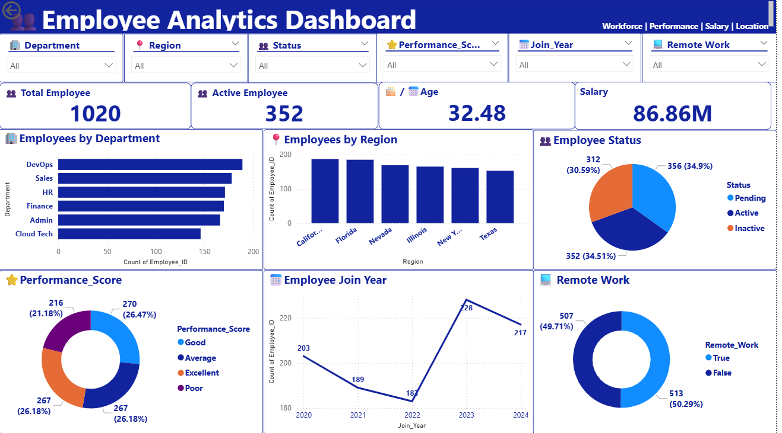

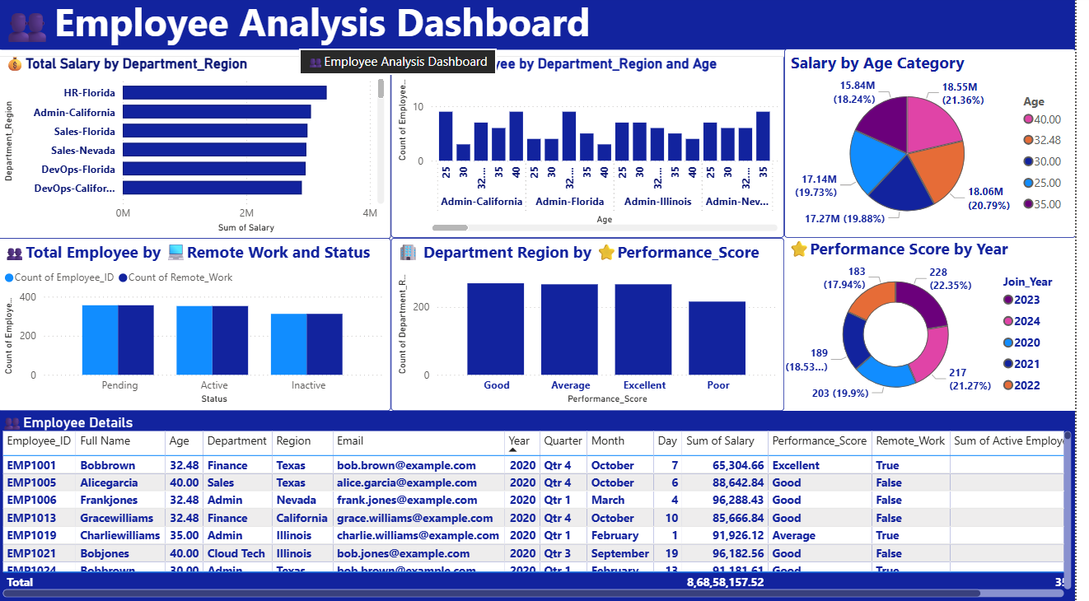

4. Key Performance Indicators
The first dashboard presents four major KPIs.
Total Employees 1,020
Active Employees 352
Average Age 32.48 years
Total Salary 86.86M
Total Employees
The organisation has a total workforce of 1,020 employees.
This provides the overall population for the remaining employee analytics.
Active Employees
There are 352 active employees, representing approximately 34.5% of the total workforce. This indicates that employee status is an important area for HR analysis because a significant portion of the workforce falls into other status categories.
Average Age
The average employee age is 32.48 years.This suggests the workforce is relatively young and may include many employees in the early and middle stages of their careers.
Total Salary
The total salary represented in the dashboard is approximately 86.86M. Salary is one of the largest employee-related organisational expenses, making salary analysis important for budgeting, compensation planning, and identifying differences across departments and regions
5. Employees by Department
The dashboard provides a comparison of employee counts across departments.The major departments shown are:
* DevOps
* Sales
* HR
* Finance
* Admin
* Cloud Tech

Analysis
DevOps has the highest employee count among the departments displayed.
Sales and HR also have relatively large employee populations, followed by Finance and Admin. Cloud Tech has the lowest employee count among the departments shown.
6. Employees by Region
The dashboard analyses employee distribution across regions including:
* California
* Florida
* Nevada
* Illinois
* New York
* Texas
California and Florida show relatively high employee counts, while Texas has the lowest count among the displayed regions.
7. Employee Status Analysis
The employee-status chart divides the workforce into:
* Pending
* Active
* Inactive The dashboard shows:
* Pending: 356 employees — approximately 34.9%
* Active: 352 employees — approximately 34.5%
* Inactive: 312 employees — approximately 30.6%
Interpretation
The relatively balanced distribution between the three categories is an important finding.
The organisation should investigate why a significant number of employees are classified as inactive or pending.
8. Performance Score Analysis
Employee performance is classified into four categories:
* Good
* Average
* Excellent
* Poor
Performance Employees Percentage
Good 270 26.47%
Average 267 26.18%
Excellent 267 26.18%
Poor 216 21.18%
Interpretation
The Good, Average, and Excellent categories have relatively similar employee counts.
However, approximately 21% of employees fall into the Poor performance category.
9. Employee Join-Year Analysis
The dashboard analyses employee joining trends from 2020 to 2024.
The displayed employee counts are approximately:
Join Year Employees
2020 203
2021 189
2022 183
2023 228
2024 217
Interpretation
Employee joining numbers decreased from 2020 through 2022.
The organisation then experienced a significant increase in hiring in 2023, reaching approximately 228 employees.
Hiring remained relatively strong in 2024 with approximately 217 employees.
This may indicate an expansion in workforce requirements during 2023–2024.
10. Remote Work Analysis
The Remote Work dashboard shows:
* True: 513 employees — 50.29%
* False: 507 employees — 49.71%

Interpretation
Remote and non-remote employees are almost equally distributed.
This indicates a relatively balanced working model between remote and non-remote employees.
The organisation can use this information to evaluate:
Further analysis can compare Remote Work vs. Performance Score to determine whether working location has any relationship with employee performance.
11. Salary by Age Category
The second dashboard analyses salary distribution by age category.
The displayed salary groups include approximately:
* 40.00
* 32.48
* 30.00
* 25.00
* 35.00
The salary distribution is relatively spread across these age categories.
Salary-by-age analysis can help HR understand whether compensation increases with employee age or career progression.
12. Total Salary by Department and Region
The dashboard provides a combined Department + Region salary analysis.
Examples include:
* HR – Florida
* Admin – California
* Sales – Florida
* Sales – Nevada
* DevOps – Florida
* DevOps – California

13. Employees by Department, Region and Age
The dashboard provides a detailed comparison of employee counts according to:
Department → Region → Age
This provides a more granular view of workforce composition.
For example, management can determine how many employees of particular age groups are working in specific department-region combinations.
This type of analysis can support:
14. Employee Status and Remote Work
The dashboard compares employee status with remote-work information.
The analysis provides an opportunity to determine whether:
* Active employees are more likely to work remotely.
* Pending employees have higher or lower remote-work participation.
* Inactive employees are predominantly remote or non-remote.
This can be particularly useful when developing hybrid and remote-work policies.
15. Department Region by Performance Score
The dashboard compares employee counts across:
* Good
* Average
* Excellent
* Poor
This helps management determine whether certain department-region combinations have stronger or weaker performance.
The Good, Average, and Excellent categories have relatively strong employee counts, while the Poor category is lower but still significant.
The organisation should investigate the causes of lower performance and develop targeted improvement programs.
16. Performance Score by Year
The dashboard also analyses performance scores across joining years.
This allows management to investigate whether employee performance varies depending on the year employees joined the organisation.
For example, HR can determine whether newer employees require more training or whether experienced employees demonstrate consistently higher performance.
Descriptive Analysis
The Employee Analytics Dashboard contains 1,020 employees with an average age of 32.48 years. There are 352 active employees, while 356 employees are pending and 312 are inactive. The total salary expenditure is approximately 86.86M. Among departments, DevOps has the highest employee count, followed by Sales and HR, while Cloud Tech has the lowest. Regionally, California and Florida have the highest employee counts, while Texas has the lowest among the displayed regions. The workforce is almost evenly divided between remote employees (513) and non-remote employees (507). Performance ratings are relatively balanced, with Good having the highest count, followed by Average and Excellent, while Poor has the lowest count.
Diagnostic Analysis
The dashboard indicates several areas that require further investigation. The number of pending employees (356) is slightly higher than active employees, which may indicate delays in onboarding, approval, or employee-status processes. The Poor performance category accounts for 216 employees, suggesting a significant group may require training, performance support, or closer evaluation. Employee numbers increased significantly in 2023, reaching 228 employees, before declining slightly to 217 in 2024. Salary distribution also varies across department-region combinations, indicating that workforce size, department, location, and salary structure should be examined together. The almost equal distribution of remote and non-remote employees suggests that remote work is an important component of the organization’s workforce structure.
Predictive Analysis
Historical employee and joining-year trends can be used to forecast future workforce requirements and recruitment needs. The increase in employee numbers during 2023 followed by a slight decline in 2024 may indicate a changing hiring pattern that should be monitored. Performance-score data can help identify employees who may require future training or development programs. Department and regional employee counts can be used to predict future staffing requirements, while salary trends can support workforce budgeting and compensation planning. Remote-work patterns can also be monitored to forecast future workplace and infrastructure requirements.
Prescriptive Analysis
The organisation should focus on reducing the number of pending employees by reviewing onboarding and approval processes. Employees in the Poor performance category should be provided with targeted training, mentoring, and performance-improvement programs. Since DevOps, Sales, and HR have relatively high employee counts, management should ensure adequate resources and workload distribution in these departments. Recruitment and workforce planning should consider the higher employee concentrations in California and Florida. Salary expenditure should be analysed by department, region, and employee performance to identify opportunities for better compensation planning. Finally, the nearly equal split between remote and non-remote employees supports maintaining a flexible work strategy while continuously evaluating productivity and employee performance.

20. Conclusion
The Employee Analytics Dashboard provides a comprehensive view of the organization’s workforce and enables management to understand employee distribution, performance, salary, location, joining trends, and remote-work patterns.
With 1,020 employees, 352 active employees, an average age of 32.48 years, and approximately 86.86M in total salary, the dashboard provides valuable information for strategic workforce management.
The analysis shows that the workforce is distributed across multiple departments and regions, while remote and non-remote employees are almost evenly divided. Performance analysis
Overall, the dashboard can help HR and management make data-driven decisions regarding recruitment, retention, compensation, employee development, performance management, workforce planning, and remote-work strategy.

